**Acceptance Testing**

**UAT Execution & Report Submission**

|  |  |
| --- | --- |
| Date | 03 November 2022 |
| Team ID | PNT2022TMID05237 |
| Project Name | Estimate the crop yield using data analytics |
| Maximum Marks | 4 Marks |

# Purpose of Document

The purpose of this document is to briefly explain the test coverage and open issues of the [Estimate the crop yield using data analytics] project at the time of the release to User Acceptance Testing (UAT).

# Defect Analysis

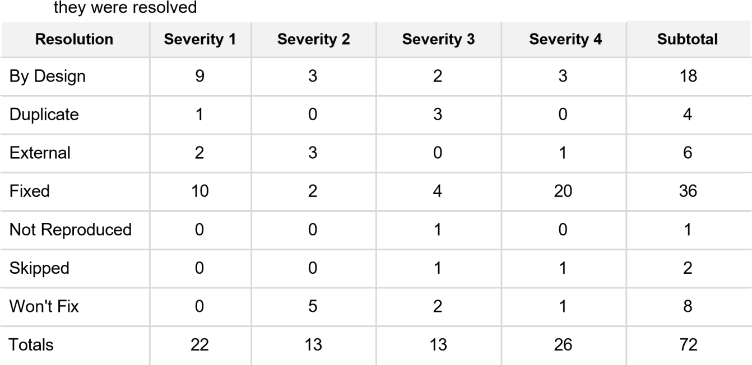This report shows the number of resolved or closed bugs at each severity level, and how

# Test Case Analysis

